
BSc. IT Management

DIARY PRO APPLICATION
(Competency Tracking)

STUDENT USER GUIDE

Version 1.0

June, 2010

Table of Contents

- Introduction

- Competencies

- What is the Student DiaryPro?

- How To Use Student DiaryPro

- How Does Student DiaryPro Work?

- How To Access Student DiaryPro.

- DiaryPro Entry Page.

- Uploading Files to a Diary Entry

- Student Report Views

- INTRODUCTION
Each student’s period on work placement affords the opportunity to learn, to achieve learning outcomes. There is a requirement to capture how the work placement learning outcomes are achieved by each student so that the process is formalised and documented. Student DiaryPro allows students to record the activities that they perform whilst on work placement, to match these activities against appropriate competencies and to reflect on individual performance and provide evidence as required.
- COMPETENCIES
What are competencies?
Competencies are personal capabilities that enable people to perform successfully by achieving outcomes or competing tasks effectively. A competency can be knowledge, skills, attitudes, values or personal characteristics. In other words, competencies describe what has to be done and how well. Competence is doing the required things to the required standard.
Professional competencies provide quantifiable means of ensuring that active learning is relevant to the programme. By constantly comparing the tasks you undertake with the contents of this document you will be able to assess the range of skills you are achieving.
There are two parts to professional competencies:
- Role Competencies
These are specific to your programme of study. They are the core skills of your profession. In human resource terminology they are called Hard Skills.
- Transferrable Competencies
These are common to all programmes. They consist of personal aptitudes and managerial capabilities. They are often referred to as interpersonal competencies because they are intertwined in your personal and professional development. In human resource terminology they are called Soft Skills.
- WHAT IS STUDENT DIARY PRO? – A Virtual Professional Diary
Student DiaryPro is an electronic add-on to the Work Placement Moodle site. It is a customised virtual professional diary version of Moodle, enabling competency tracking.
Student DiaryPro should be used regularly, typically on a weekly basis. The emphasis is on reflection on tasks carried out and matched against competencies. Participants should attempt to achieve as many competencies as possible whilst on placement.
The diary system is online and is a managed and interactive system that enables the tutor to monitor, on a real-time basis, the progress of the student. The student can also set personal goals, claim the achievement of competencies and read reviews of progress from his/her tutor.
Students claim competencies based on diary entries and these are analysed by a feature which generates overview reports. These reports are then reviewed by tutors who can then advise students on the balance of competencies being claimed and can detect any imbalance that needs correction.
Students must reflect on how their experience merits credit towards competencies being claimed. The students’ view of work activity and experience should be more focused towards the learning value involved. Students can view source material and reference guides and upload assignments in the usual virtual learning environment fashion.
- HOW TO USE STUDENT DIARYPRO
Students are required to make entries to Student DiaryPro, outlining the tasks that they have undertaken during work placement. Students will enter the relevant diary code from the following table.
The following are the relevant entries for the BSc. (Ord) IT Management students.
- ITMGT Transferrable and Interpersonal Skills
- ITMGT Key Skills
CATEGORY CODE: ITMTRANS
CATEGORY: ITMGT Transferrable and Interpersonal Skills
CATEGORY TOPICS
Write Reports | Give Oral Presentations | Work Independently on Projects with clearly Defined Objectives
Use People Management Skills | Communicate effectively with professionals in the field of computing, management and information | Provide Leadership in the Working Environment, Supporting and Developing Team Members
Work in Multidisciplinary Groups | Work as a member of a team or as a team leader | Operate in a professional, responsible or an ethical way
Take responsibility for work and presentation of results | Other Transferrable and Interpersonal Skills

CATEGORY CODE: ITMKS
CATEGORY: ITMGT Key Skills
CATEGORY TOPICS
Understand the role ICT plays in the business environment you are working in | Analyse and Manage Financial Information as it relates to your role in the IT Organisation | Implement and support professional and legal aspects of IT Management
Keep abreast of current trends in software and information systems | - Keep abreast of current trends in software and information systems | - Ensure that quality assurance mechanisms for your tasks were adhered to
Complete a mini-project on time and to specification | - Develop, review and select appropriate techniques, procedures and methods to undertake computing tasks | - Operate with the financial and commercial constraints of an organisation and the overall statutory framework
Integrate knowledge and skills across a number of areas e.g. networks and security, software testing and finance | - Be able to objectively question existing technical operations | - Demonstrate an awareness of the role IT and IT professionals play in business and the critical/active contribution they can make to the work place
Design and develop web applications | - Manage system maintenance requests | - Plan and carry out comprehensive system testing
Knowledge and understanding of the day-to day operation of an IT Department | - Knowledge and understanding of the software and hardware technologies used by the work placement employer to provide reliable applications to the business | - The principles required to successfully build and manage information systems
Participate in the identification of operational and service problems, evaluation of options and formulations of solutions | - Select, implement and manage local and wide-area networks | - Develop and configure data communication systems
Install and administer a server | - Implement and manage and support database solutions | - Perform database administration tasks
Use operating system packages effectively | - Manage and support application software – batch processing, recovery, production activity, backup and contingency planning | - Keep up-to-date with security techniques and solutions
Develop or enact organisational security procedures | Other IT management key skills

Ideally, you should obtain as broad a range of competencies as possible. We recognise that your workplace learning may be confined to a limited field of experience and may result in concentrated practice in a particular competency area. It is, however, possible to accumulate experience in other areas by a number of methods, for example:
- Discuss the situation with your supervisor with the view to gaining other competencies
- Engage with other members of the team. You could, for instance, ask to be an observer at meetings.
- Many competencies can be gained by studying documentation and gaining an understanding of the area of work e.g. various policy documents.
- Be proactive and get involved. Ask questions. Learn how the agency is organised.
- HOW DOES STUDENT DIARYPRO WORK?
A set of competencies are recorded, these should already be in existence in the programme schedule and module learning outcomes. Competencies are personal capabilities that enable a person to perform successfully. They are the achievement of outcomes and the completion of tasks effectively. The initial work consists of drafting and input of competencies. Now the student can commence diary entries that are matched against these competencies. Student DiaryPro is very simple to use and it also captures the number of hours you have spent on a particular task.
You can also attach multiple files as evidence, in varying formats on one entry.

- HOW TO ACCESS STUDENT DIARYPRO
- Log onto Moodle in the normal manner.
- Open the Work Placement module course page.
- On the Moodle Work Placement course page, the diary is accessed from the block on the left hand side of the page called Student Diary Pro [Go to Student Diary Pro(STD)].
- In the example below, the Student Diary Pro is located on the lower left hand side of the Moodle Work Placement [SDP Test] page.
- Click < Go to Student Diary Pro> to access DiaryPro.

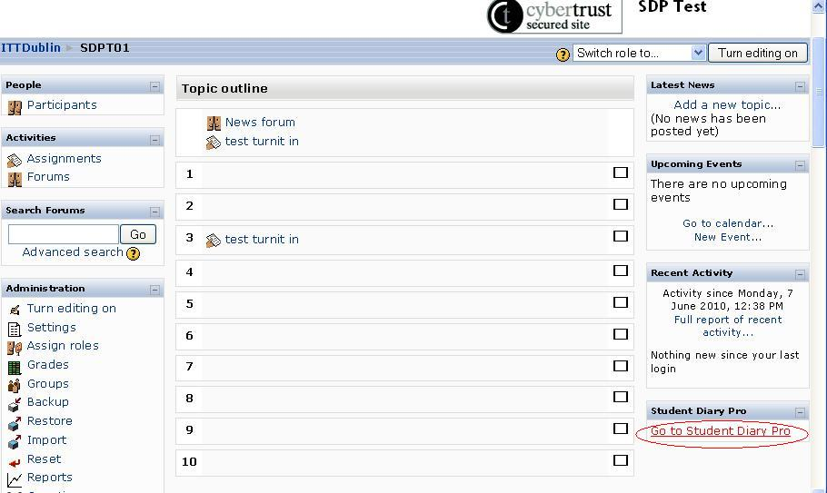
Figure 1: Work Placement Module - Moodle Page (2010)
This will bring participants to their DiaryPro entry page.

- DIARYPRO ENTRY PAGE
- Entries can be added via the link [Add Diary Entry]. The screen shot below displays an example of a previous entry. This example does not yet include competencies achieved and diary entry attachments.
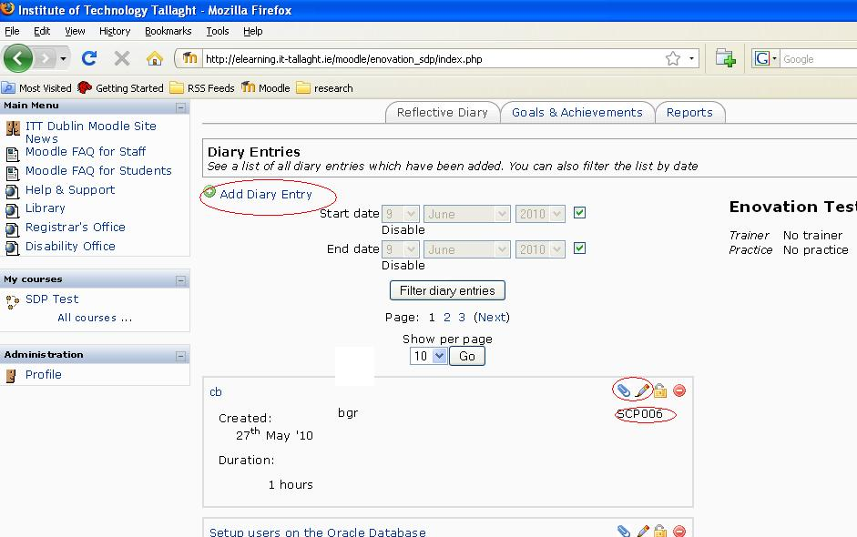
Figure 2: DiaryPro Student Home Page (2010)

(2) The screen shot below displays previous entries, and includes competencies achieved and attachments to the diary entries. Examples are circled in red below.
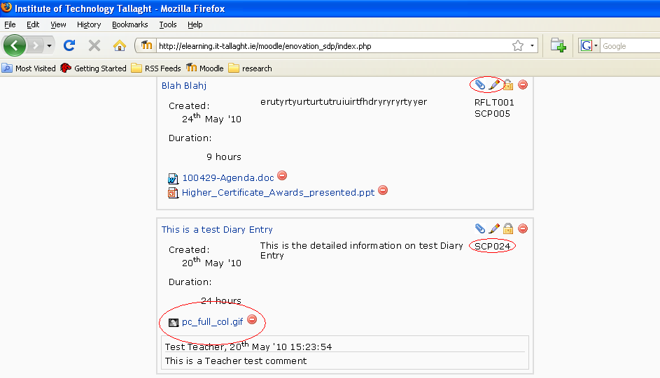
Figure 3: Examples of DiaryPro Participant Entries (2010)

- Click on [Add a Diary Entry].
Once [Add a Diary Entry] is selected, the participant will be brought to the screen below to add the diary details.
- Enter dates as per calendar [From] and [To]
- Enter duration, if required in hours
- Complete [Brief Description], e.g. “Taking minutes at meeting”.
- Complete [Detailed Description]. Here you can describe in detail the tasks performed.
- Now scroll down [Select Category] menu and choose the category that the task fits into e.g. ITMGT Key Skills
- When you select the Category, the competencies will appear in the drop down box below and you can choose the appropriate match e.g. “Keep abreast of current trends in software and information systems”. Note the competency code: ITMKS04. Each competency has a unique competency code.
- Now click [Add to Selected Competencies].
- At this point you can repeat this exercise if you feel more than one competency was involved.
- When you are happy that you have recorded the competencies, you can click [Save].
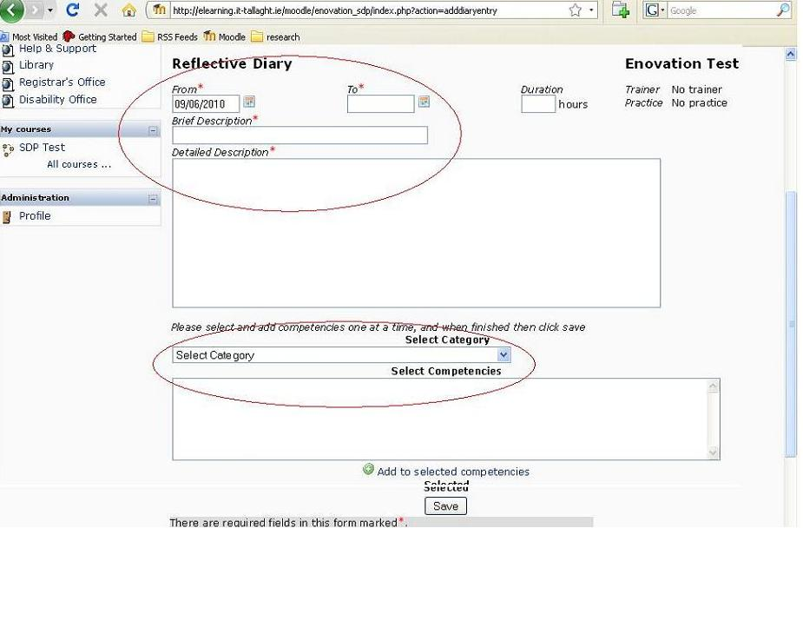
Figure 4: DiaryPro Participant Reflective Diary Entry Screen (2010)
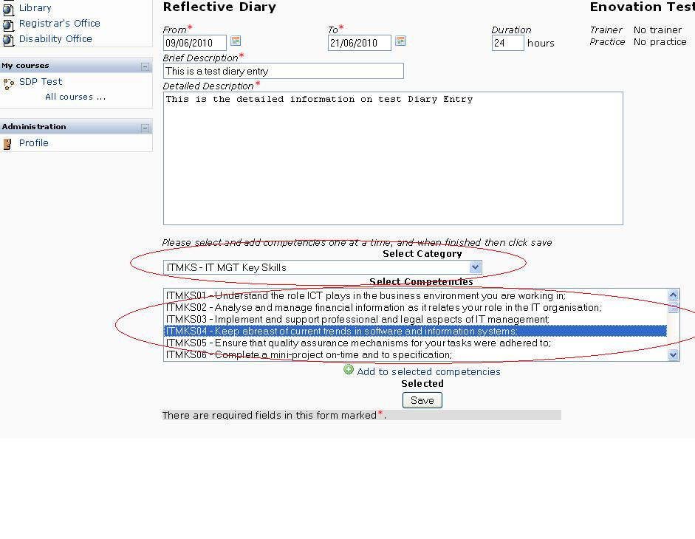
Figure 5: Reflective Diary Completed Data Example (2010)
- Now you will see your saved data entry.
- You can now attach evidence in the form of any file by clicking on the [paper clip symbol] and browsing and attaching the appropriate file.
- If you wish to edit or amend you entry, click on the [pencil symbol] .
- If you wish to delete your entry click on the [red button] on the right hand side of the entry.
- You can also lock your entry by clicking on the [padlock button] . This can prevent accidental deletion.

- Details are added to the necessary fields with competencies selected in the lower fields. The red asterix * warrants pre-filled data as well as the addition of the competencies.
- Below is an example of completed data. (Note the competencies when the category is selected).

- The screen shot on the next page displays the above entry added to the diary.
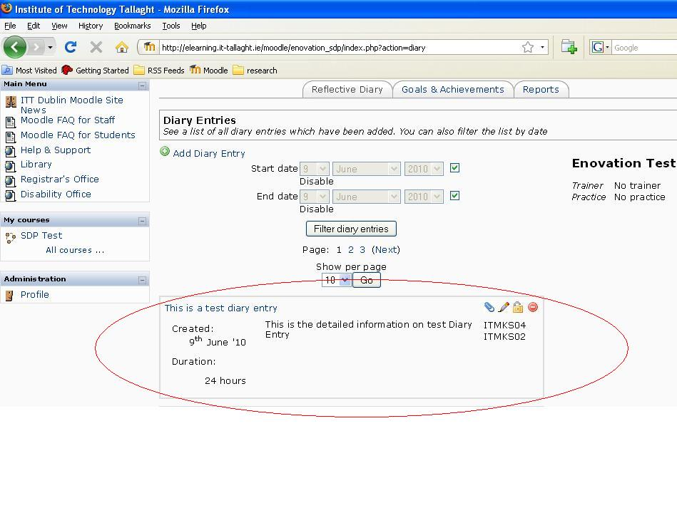
Figure 6: Data added to the Diary - Example Screenshot (2010)

- UPLOADING FILES TO A DATA ENTRY
- Files can be attached via the paper-click icon circled below.
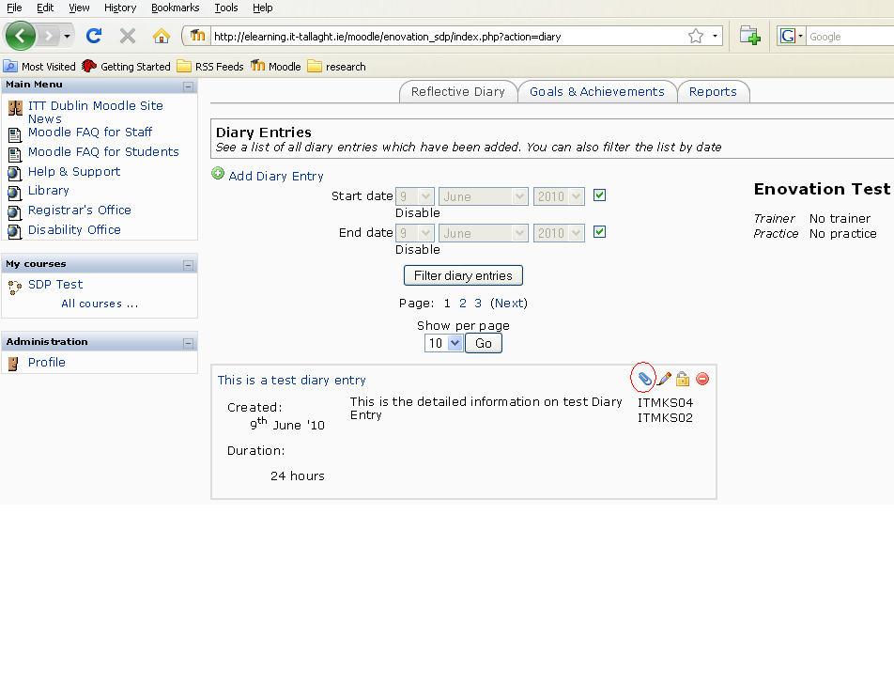
Figure 7: Use Paperclip Icon to Attach Files to a Data Entry (2010)
- Browse to the location on your PC to upload your desired file.
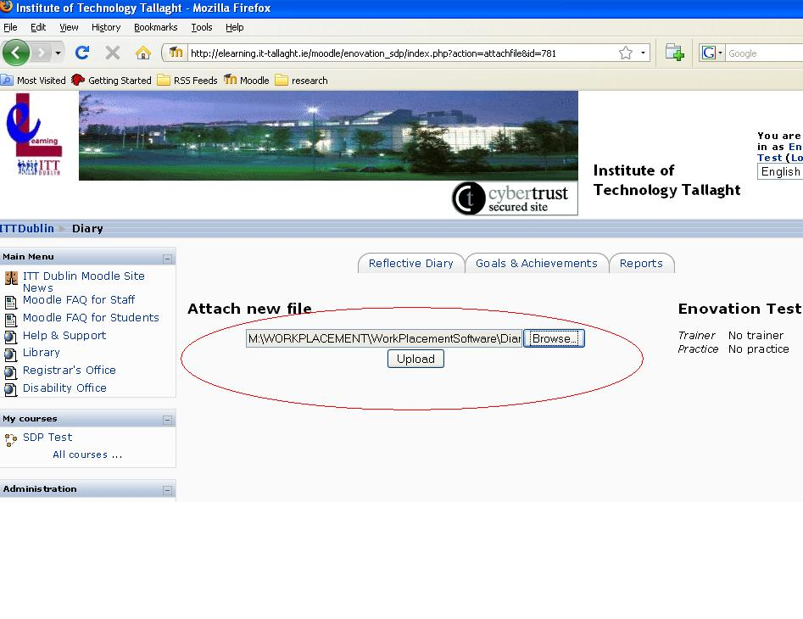
Figure 8: Attaching a new File to a Data Entry (2010)
- The desired file is added to the entry (circled below).
Figure 9: Data Type Upload Examples (2010)
- STUDENT REPORT VIEWS
Students can view reports by clicking on the [Reports] tab icon on the Student DiaryPro home page. There are two main types of reports. A student can view the number of entries made and also the competencies added by the student.
- Participants can view an overall report of their diary from the reports tab circled below.
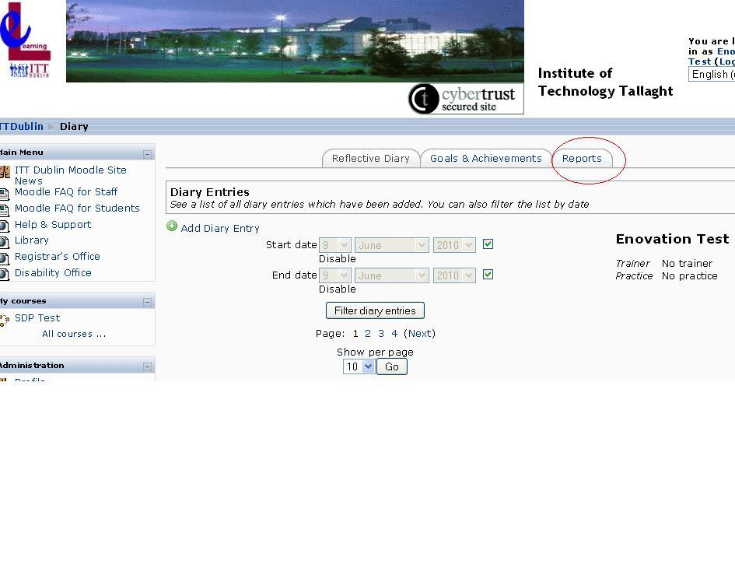
Figure 10: Access Report Features (2010)

- This gives a participant of their diary, achieved competencies and the associated attachments.
- View the number of diary entries made
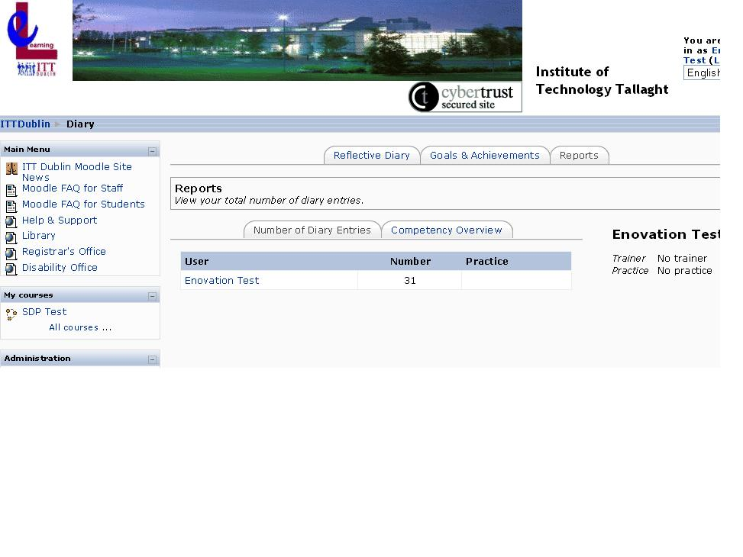
Figure 12: Number of Diary Entries Made Report (2010)
- View a list of your competencies added.
Students can see at a glance what competencies have been met. A competency that is met has a green tick (attachments are identified by the paperclip symbol ). and a competency that has not been met is depicted by a red .
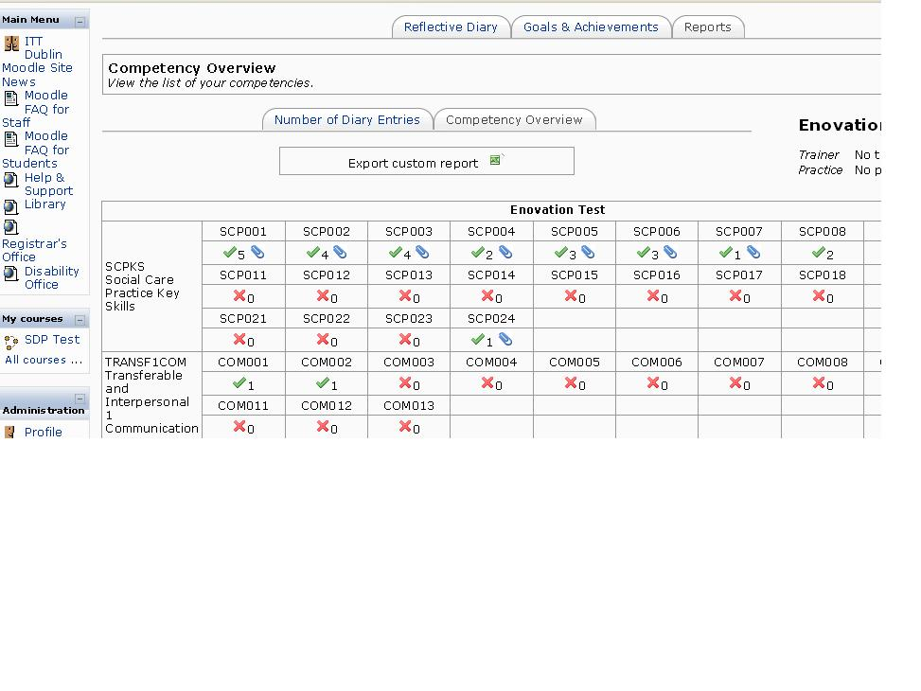
Figure 13: List of Competencies Added Report (2010)

